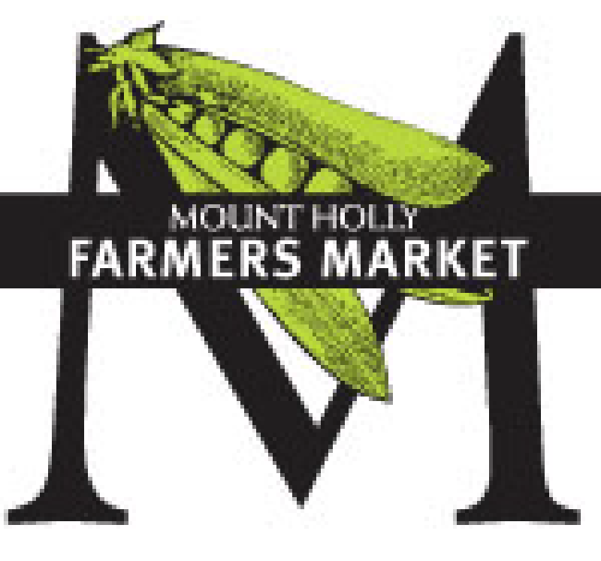
Mount Holly Farmers Market
Grower/Producer & Value Added Products
Vendor Rules & Guidelines

- DATES OF THE MARKET: The MHFM will be open for seasonal operation, with dates to be determined each year. Opening Day: ___________ Closing Day: ___________ Additional dates may be added at the discretion of the Board of Directors.
- TIME /LOCATION FOR MARKET SALES: The MHFM will operate in the parking lot for 226 S Main St, Mount Holly on Saturdays from 8:00 am until 12:00 noon. Market staff and vendors may buy from each other prior to the market opening. Vendors are asked to be in place by market opening with vehicles moved from areas that would impede foot traffic and safety of those in the shopping area.
- VENDOR ATTENDANCE: Vendors must notify the Market Manager by 6:00 p.m. Friday if they are unable to attend the market for any reason. This is to allow for adjustment in placement and setup of the market.
- SPACE ASSIGNMENT: Spaces are assigned at the discretion of the Market Manager with consideration of the good of the market, vendor preference, attendance commitment, category differences/compatibility of products, quality and quantity of products, and previous space assignment. Prospective new vendors must apply to the Board and be approved before they can sell at the market.
- PRODUCER-ONLY RULES AND EXCEPTIONS: The goal of the MHFM is to support local agriculture, defined as within 75 miles of the market site. As such, all products displayed must be produced by the producer/vendor who sells them or obtained through a partnership with another local producer, allowing that this partnership is disclosed on the application and proper signage is on display noting the origin of the product. The producer may be a sole proprietorship or partnership. The vendor on site may be the actual producer, an immediate family member, another producer in the market, staff or employee of the producing individual. Exceptions may be made to the local producer rule on a case-by-case basis for products not available within the local area. These cases must be brought to the Market Manager for approval in collaboration with the Board of Directors.
- ALLOWABLE PRODUCTS: Producers/vendors shall submit a plan with their application at the beginning of each season, indicating all crops and products they plan to sell during the market season. Any products wished to be added after the application must be approved by the Market Manager prior to bringing to sell. Products are likely to fall in the following categories:
- Vegetables/fruits/herbs including mushrooms.
- Fresh baked goods from scratch (no store-bought mixes) produced in a kitchen that has been inspected and certified in accordance with health codes.
- Cheese and other value-added products from milk produced on the producer/vendor farm or purchased from a local dairy farm. All dairy products must be pasteurized and in accordance with the state and county health codes. If milk purchased, vendor must provide the Market Manager with the name and contact information of the dairy farm.
- Cut flowers grown on the grower’s own farm or greenhouse or obtained through partnership with another local producer.
- Eggs which are from the producer/vendor’s own poultry or obtained through partnership with another local producer and stored at 41 degrees F during the market.
- Jams, honey and other value-added products which are freshly made by the vendor (no store-bought mixes) using seasonal ingredients from their farm or another local farm. Processing must comply with local health codes. Products used to make ciders or juices must be from the producer’s farm or that of another local farm, but may be processed off-farm. Vendors must provide the Market Manager with the name and contact information of the processing facility.
- Soaps and body products hand-crafted using ingredients from their farm or another local farm.
- Meat from livestock raised by the producer/vendor and processed at a USDA inspected facility. Meat vendors must have a meat handler license.
- Potted plants, shrubs or annual bedding plants which have been raised from seeds, sets/tubers/bulbs, or cuttings. Greenhouse operations must be approved by the Board on an individual basis in accordance with local and state ordinances.
- Seafood raised or caught in Carolina waters. Exceptions may be approved based on local availability.
- Other farm products not listed here may be sold on a provisional basis on request to the Market Manager and review of the Board of Directors as needed.
- VENDOR QUALIFICATION/ MEMBERSHIP FEES: All persons requesting membership with permission to sell at the MHFM must: File a vendor application each year with the Market Manager. This document requires the producer/vendor to verify that they are the actual grower or producer of the specified items that they intend to sell, or disclose information regarding a partnership with another local producer and provide appropriate contact information for that producer. Vendor may request an exception to the local production rule as listed above on a case by case basis for products not available within the local area. A site visit of applicant’s site as well as any partner sites may be requested prior to approval to participate.
- Demonstrate compliance with applicable city/state/federal food safety, sanitation and health regulations appropriate to the product category by providing the Market Manager copies of documents such as, but not limited to: agricultural business license, NCDA & CS kitchen inspection, water test certification, meat handler license, and NCDA & CS inspection of nursery stock required for selling whole plants, replanting packs and pots. Vendors must also use appropriate product labeling with NC or federal inspection stamp when required. USE OF ORGANIC LABEL: Growers using the label “organic” in any representation of their product must have a copy of their Organic Certification on file with the Market Manager. If a grower sells less than $5000 worth of produce annually, that individual may use the term “organic” in describing their produce only if they have signed the “Small Scale Organic Growers Declaration of Exemption from Certification” form. A copy must be on file with the Market Manager.
- Pay the annual membership dues for the MHFM in the amount of $20.00 to be submitted to the Market Treasurer no later than the opening day of the market or first day of sales. Dues are not pro-rated for late-season applications.
- Pay a fee of $10.00 per week for a 10’ x 10’ space. Full time vendors in good standing with the market shall receive first priority. The weekly fee covers provision of a tent, two tables, two tablecloths and a chair. Additional tables, cloths or chairs may be available on request as available. Additional fees will be charged for additional tent space reserved.
- NC statutes about specialty markets require that farmers market operators keep a registration list of vendors. Per current NC Department of Revenue guidelines, all vendors required to collect sales tax must provide the market operator with their NCDR certificate of registration number and prominently display a copy of their registration at their booth. Those exempt from collecting sales tax must provide the operator their agriculture exemption number or attest in writing that they are selling only their own farm products at the market.
- EDUCATIONAL/COMMUNITY ACTIVITIES/SERVICE ORGANIZATIONS: Space will be provided free of charge for educational activities related to sustainable agriculture, healthy eating (seasonal and local) and non-profit community groups, based on space availability. These must be approved and scheduled in advance by the Market Manager. No petitions or other printed material, political or otherwise, will be distributed or displayed at the Market without prior approval by the Market Manager. One space will be held by the MHFM to be used for market management, promotional and educational purposes. The Market space may also be used to provide seasonal produce for purchase.
- MARKET SIGNAGE: Producers/vendors will display a sign identifying the name and location of their farm/business and any partner farms/businesses. Contact person name and a method of contact should be available on request of the customer. The producer/vendor must have a sign, tags or labels listing the prices of all items for sale. Signs must be posted before sales begin. Any signs must allow visibility and access to adjoining booths. Signs must also be present noting the origin of any products not grown/produced by producer/vendor selling those goods.
- CLEAN-UP: Producers/vendors are expected to clean up the booth area before leaving. Trash can(s) are provided.
- PUBLIC SAFETY/ HEALTH PRACTICES:
- All producers/ vendors must adhere to sanitary procedures. Any vendor found selling contaminated foodstuffs or produce shall be suspended from selling operations.
- Recycled produce bags and egg cartons are discouraged.
- Distribution of food samples is allowed providing the following sanitary conditions exist: Samples shall be personally distributed only by the seller to the customer on a one-to-one basis. Convenience items such as toothpicks and napkins must be supplied as needed. Customers are not to serve themselves. Samples shall be kept in approved, clean, covered containers. Clean, disposable gloves shall be used when cutting samples. Food intended for sampling shall be washed, clean of soil or other material in order that it be wholesome and safe for consumption. Potentially hazardous food samples, shall be maintained at or below 45 degrees F. All other food samples shall be disposed of within two hours after cutting.
- REFUND POLICY: All producers/vendors selling at the MHFM shall guarantee the quality of the products they offer. This shall apply to any food, plant or any other item sold at the Market. If an exchange or other arrangement is not acceptable to the customer, a refund in the same kind as the payment, usually cash, must be offered by the vendor. In order to qualify for a cash refund, the customer must return the unused portion of the product in question. Refunds shall be given within seven days from the time of purchase. Refund requests beyond a seven-day period from the time of purchase will be honored only at the discretion of the producer/vendor.
- SMOKING: A “No Smoking” policy is in effect at the market.
- ALCOHOL: No alcoholic beverages permitted at the market.
- PETS: No pets belonging to producers/vendors are permitted. Customers’ pets that are well-behaved are welcome if controlled on leash. The Market Manager reserves the right to request that any pet disruptive to the market atmosphere or safety of its participants be removed.
It is the responsibility of the Market Manager to ensure compliance with the market rules, however, the Market Manager has the authority to grant exceptions to the rules on an individual basis. Should a grievance arise regarding the application of a policy, procedure, rule, or action, one may file a grievance following market grievance procedures. Approved 1/25/2017

